Rudolph Hennig Junior High School

Basic Supply List for Grades 7, 8, and 9 (2023/24)

General (All Students Grades)

- Binders (number and size based on student preference)
- Dividers (number and size based on student preference)
- Loose leaf
- Erasers
- Highlighters
- Pencils
- Pencil crayons
- Pencil case
- Pens (blue or black pens & red marking pens)
- Scissors (optional)
- Geometry set
- 1 Package of tracing paper (for Math)
- Calculator (see below for detailed information)

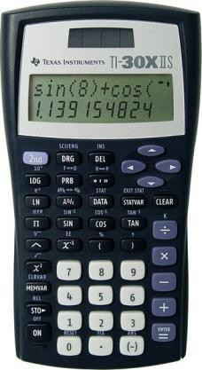
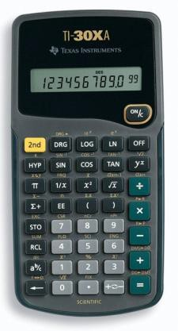
Calculator Requirements

  - Students in Grade 7 and 8 require a “basic” calculator with:
    - Square root key

  - Students in Grade 9 require a “scientific” calculator with:
    - Square root key o Integer key
    - Fraction key o Exponent key
Note: Not all “scientific” calculators have these keys.
Recommended: TI-30XA or TI-30X by Texas Instruments, if available.

Optional Supplies

- White-out correction tape (No liquid)
- 1 Package of blank paper (approximately 200 sheets)
- 1 Package of reinforcements
- 1 Package of Post-It notes
- Handheld pencil sharpener
- 30 cm clear plastic ruler
- Duotang
- Coiled notebook

Physical Education (all students)

  - T-shirt
  - Shorts or jogging pants
  - Socks
  - Sweatshirt
  - Indoor shoes with non-marking soles
  - Antiperspirant/Deodorant (no body sprays)

